**Ex. No. : 03 Date: 28/04/2025**

**Register No.: 221701050 Name:D Sathiya Sri**



**Graphical Primitives**

**Aim**

Develop an android application to draw the circle, ellipse, rectangle and some text using Android Graphical primitives.

***Procedure:***

1. Create a New Android Project

* Open Android Studio.
* Create a New Project with Empty Activity.
* Select Kotlin as the programming language.

2. Design the Layout (activity_main.xml)

* Open activity_main.xml.
* Use a FrameLayout or RelativeLayout to hold the custom drawing view (CustomDrawView).

3. Create a Custom View Class (CustomDrawView)

* Create a new Kotlin class called CustomDrawView.kt extending View.
* Override the onDraw() method to draw shapes and text:  
  + Circle using canvas.drawCircle()
  + Ellipse using canvas.drawOval()
  + Rectangle using canvas.drawRect()
  + Text using canvas.drawText()

4. Add the Custom View to Main Activity

* Open MainActivity.kt.
* Set the custom CustomDrawView as the content view of the activity.

5. Run the Application

* Build and run the app on an emulator or physical device to see the shapes and text.

6. Customize (Optional)

* Adjust the colors, sizes, and positions of the shapes or text in the CustomDrawView class.
* Add more shapes or interactions if needed.

***AndroidManifest.xml***

<?xml version="1.0" encoding="utf-8"?>

<manifest xmlns:android="http://schemas.android.com/apk/res/android"

xmlns:tools="http://schemas.android.com/tools">

<application

android:allowBackup="true"

android:dataExtractionRules="@xml/data_extraction_rules"

android:fullBackupContent="@xml/backup_rules"

android:icon="@mipmap/ic_launcher"

android:label="@string/app_name"

android:roundIcon="@mipmap/ic_launcher_round"

android:supportsRtl="true"

android:theme="@style/Theme.Exp3"

tools:targetApi="31">

<activity

android:name=".MainActivity"

android:exported="true">

<intent-filter>

<action android:name="android.intent.action.MAIN" />

<category android:name="android.intent.category.LAUNCHER" />

</intent-filter>

</activity>

</application>

</manifest>

***Activity_main.xml***

<?xml version="1.0" encoding="utf-8"?>

<RelativeLayout xmlns:android="http://schemas.android.com/apk/res/android"

android:layout_width="match_parent"

android:layout_height="match_parent">

</RelativeLayout>

***MainActivity.kt***

package com.example.exp_3

import android.graphics.Canvas

import android.graphics.Color

import android.graphics.Paint

import android.graphics.RectF

import android.os.Bundle

import android.view.View

import androidx.appcompat.app.AppCompatActivity

class MainActivity : AppCompatActivity() {

override fun onCreate(savedInstanceState: Bundle?) {

super.onCreate(savedInstanceState)

val drawView = object : View(this) {

private val paint = Paint()

override fun onDraw(canvas: Canvas) {

super.onDraw(canvas)

paint.color = Color.BLUE

paint.strokeWidth = 5f

paint.style = Paint.Style.FILL

canvas.drawCircle(200f, 200f, 100f, paint)

paint.color = Color.RED

val rect = RectF(350f, 150f, 550f, 250f)

canvas.drawOval(rect, paint)

paint.color = Color.GREEN

canvas.drawRect(100f, 300f, 400f, 500f, paint)

paint.color = Color.BLACK

paint.textSize = 50f

canvas.drawText("Hello, Android!", 100f, 600f, paint)

}

}

setContentView(drawView)

}

}

***Output***

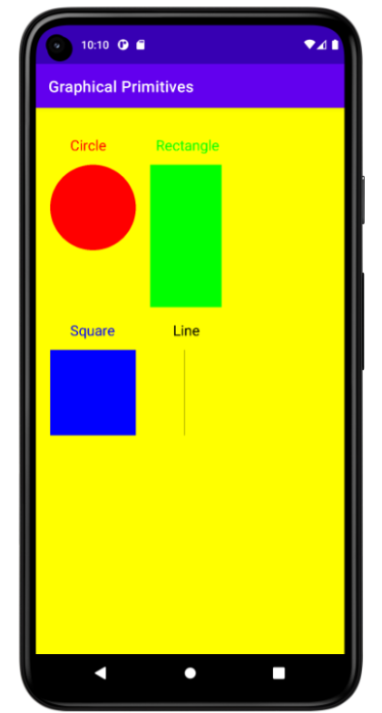

**Result:**

| The app is successfully created. It draws a circle, ellipse, rectangle, and text on the screen. You can customize the design and add more features if needed. |
| --- |